Technical Committee for Pressure at DKD:
Christian Elbert remains chairman
Klingenberg, January 2011.
Christian Elbert, Deputy Head of the Calibration Division at WIKA, has been re-elected as chairman of the Technical Committee for Pressure at the German Calibration Service (DKD). The committee represents the interests of more than 60 accredited pressure calibration laboratories in Germany.
The certification of specified quality standards, in accordance with EU regulation, is now a central sovereign function. The Federal Ministry of Economics and Technology, responsible for this, has therefore commissioned the newly founded German Accreditation Body (DAkkS).
From this step, as Christian Elbert stresses, those services for the control and inspection of test equipment, previously certified by DKD and recognised internationally for their quality, remain untouched. However, there is a visual change: the previously red calibration label will, in the future, be blue. Red is, according to Christian Elbert, too widely perceived as a warning signal colour and not as evidence of proven accuracy. Further information is available on the internet at www.dakks.de.

Number of characters: 1169
Key word: Technical Committee for Pressure

Manufacturer:
WIKA Alexander Wiegand SE & Co. KG
Alexander-Wiegand-Straße
63911 Klingenberg, Germany
Tel +49 9372 · 132 – 0
Fax +49 9372 · 132 – 406
E-Mail sales@wika.de
Internet www.wika.de

WIKA company photograph:
Christian Elbert (WIKA, Klingenberg), Chairman of the Technical Committee for Pressure in the German Calibration Service (DKD)

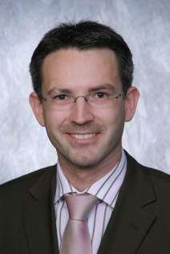

Edited by:
WIKA Alexander Wiegand SE & Co. KG
André Habel Nunes
Marketing Services
63911 Klingenberg, Germany
Tel +49 9372 · 132 - 806
Fax +49 9372 · 132 - 9803
E-Mail a.habel-nunes@wika.de
Internet www.wika.de

WIKA press release 01/2011

