Compact digital pressure gauge with high accuracy

Klingenberg, January 2012.
WIKA has expanded its offer of digital pressure gauges with the versatile model CPG500. The new compact instrument offers a high degree of measuring accuracy and speed.

A digital pressure gauge combines the accuracy of digital technology with the simplicity of an analogue pressure measuring instrument. Given its very high sampling rate of 100 measurements per second, the CPG500 is ideally suited for capturing fast pressure peaks and drops. It also operates with a high accuracy of 0.25 % of span. Thus the new instrument can be used both for pure pressure measurement and for the calibration of most analogue pressure gauges.

In addition, the CPG500 impresses with its robust case and its simple, four-button operation. These features enable it to be used in a wide variety of applications.

The CPG500 is a cost-effective alternative to the model CPG1000 precision digital pressure gauge. This is also a robust product, which mainly differs by having a better accuracy of 0.05 % of span, as well as through its ATEX certification. An integrated data logger also offers the possibility of saving the measured values to a PC for analysis.

The digital pressure gauge programme from WIKA is completed by the proven service cases for calibration. Among other things, they enable the user to have mobile pressure supply on site.

Number of characters:
Key word: CPG500

Manufacturer:
WIKA Alexander Wiegand SE & Co. KG
Alexander-Wiegand-Straße
63911 Klingenberg
Tel +49 9372 132 – 0
Fax +49 9372 · 132 – 406
E-mail sales@wika.de
Internet www.wika.de

WIKA company photograph:
Digital pressure gauge CPG500

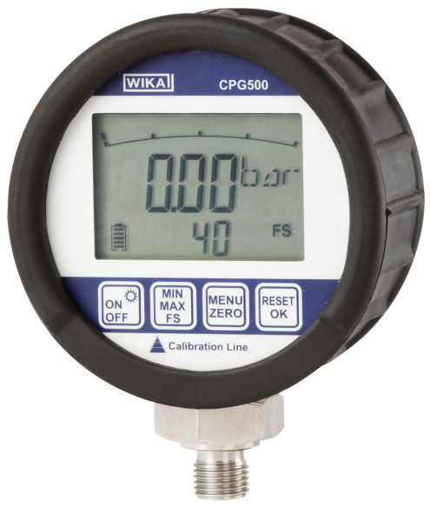

Edited by:
WIKA Alexander Wiegand SE & Co. KG
André Habel Nunes
Marketing Services
Alexander-Wiegand-Straße 30
63911 Klingenberg/Germany
Tel. (+49) 9372 132-8010
Fax (+49) 9372 132-8008010
E-mail a.habel-nunes@wika.de
www.wika.com

WIKA press release 01/2012

