Electronic Pressure Measurement

WIKA authors write about basics, applications and instrument selection

Klingenberg, March 2010.
In the renowned technical book series of the publisher “Verlag Moderne Industrie” a volume about electronic pressure measurement has been released with the technical support of WIKA. The authors are Eugen Gaßmann and Anna Gries.
The book series from Süddeutscher Verlag onpact/Verlag Moderne Industrie has striven over the past 20 years to communicate, in a compact way, basic technical principles in conjunction with the know-how of leading companies.The new title, "Electronic Pressure Measurement", is already their 323rd volume.
Eugen Gaßmann, Head of Product Management in WIKA's TRONIC company division, and his colleague Anna Gries give a comprehensive overview of basic principles, instruments and typical applications in electronic pressure measurement technology, before they offer a detailed set of criteria for the practical selection of instruments.
The colour-illustrated, 72-page hardback book is available from specialist shops as well as directly from WIKA.

Number of characters: 1098
Code word: Technical book "Electronic Pressure Measurement“

Manufacturer:
WIKA Alexander Wiegand SE & Co. KG
Alexander-Wiegand-Strasse
D-63911 Klingenberg
Tel. +49 · 9372 · 132-0
Fax +49 · 9372 · 132-406
E-Mail Vertrieb@wika.de
Internet www.wika.de

WIKA company photograph:
"Electronic Pressure Measurement" is a new title of the technical book series from the publisher Süddeutscher Verlag onpact, Munich. The book has been produced with the technical support of WIKA Alexander Wiegand SE & Co. KG. The authors are Eugen Gaßmann and Anna Gries.
72 pages, 39 colour illustrations, 3 tables. Hardback.

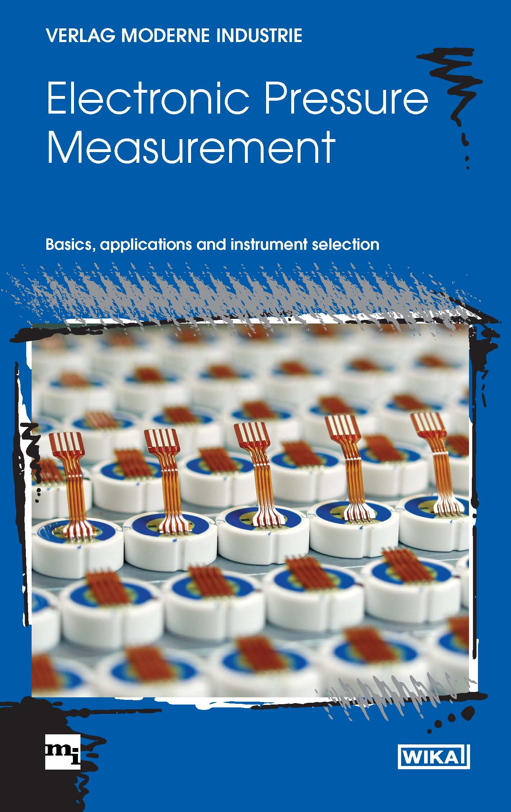

Edited by:
WIKA Alexander Wiegand SE & Co. KG
André Habel Nunes
Marketing Services
63911 Klingenberg, Germany
Tel +49 · 9372 · 132-806
Fax +49 · 9372 · 132-423
E-Mail a.habel-nunes@wika.de
Internet www.wika.de

Press release 03/2010

