New measuring option displays
overpressure with 100% certainty

Klingenberg, March 2011.
For two pressure gauge series, WIKA has now developed a novel overload indicator. With it, unexpected overpressures in industrial processes can be documented beyond any doubt.

The advantage over a pressure gauge with a drag pointer lies in the guaranteed security of the indication. The status of drag pointers can alter due to external influences such as vibration, and thus the explicit confirmation of overpressure cannot be ensured. In addition the new overload indicator is protected against any manipulation after the fact.

The core of the new instrument option is a spring pin. This is fitted at the dial's scale value which the customer has defined as the highest pressure. The indicator, an aluminium pin, is carried by the instrument pointer, and if the designated maximum pressure is exceeded, it is locked permanently in the red zone.

WIKA supplies the overload indicators for model 23x.50 and 212.20 bourdon tube pressure gauges in nominal sizes of 100 and 160.

Number of characters: 1058
Key words: Overload indicator

Manufacturer:
WIKA Alexander Wiegand SE & Co. KG
Alexander-Wiegand-Straße 30
63911 Klingenberg/Germany
Tel. (+49) 9372 132-0
Fax (+49) 9372 132-406
E-mail sales@wika.de
www.wika.com

WIKA company photograph:
Bourdon tube pressure gauge with overload indicator

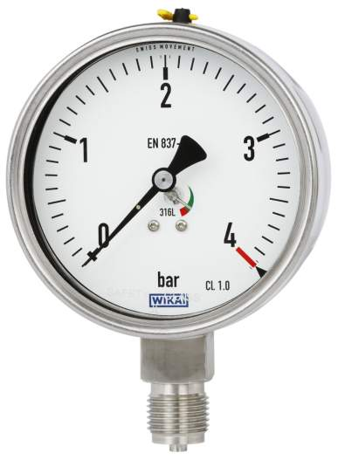

Edited by:
WIKA Alexander Wiegand SE & Co. KG
André Habel Nunes
Marketing Services
Alexander-Wiegand-Straße 30
63911 Klingenberg/Germany
Tel. (+49) 9372 132-806
Fax (+49) 9372 132-9803
E-mail a.habel-nunes@wika.de
www.wika.de

WIKA press release 03/2011

