WIKA MG-1 pressure transmitter for
safe application with medical gases

Klingenberg, March 2011
For the pressure measurement of medical gases and, in particular, of oxygen, WIKA has developed the MG-1 pressure transmitter. It fulfills the high demands placed on instruments in contact with oxygen in order to avoid any risk to safety.

The MG-1 uses materials that are specifically suited to medical oxygen applications and are approved by the German Federal Institute for Materials Research (Bundesanstalt für Materialforschung - BAM). In addition, it fulfills the stringent purity requirements in accordance with internationally accepted standards for oxygen service.
In line with the international directives, different levels of cleanliness, different packaging and instrument markings are available.
Through its flexibility, the MG-1 can be used in all medical oxygen applications, from storage to distribution and also supply: whether in hospitals, in home care or in ambulances.

Number of characters: 980
Key words: Pressure transmitter MG-1

Manufacturer:
WIKA Alexander Wiegand SE & Co. KG
Alexander-Wiegand-Straße
D-63911 Klingenberg
Tel +49 9372 132 – 0
Fax +49 9372 · 132 – 406
E-mail sales@wika.de
Internet www.wika.de
WIKA company photograph:
WIKA MG-1 pressure transmitter for medical gases,
optimised for oxygen applications.

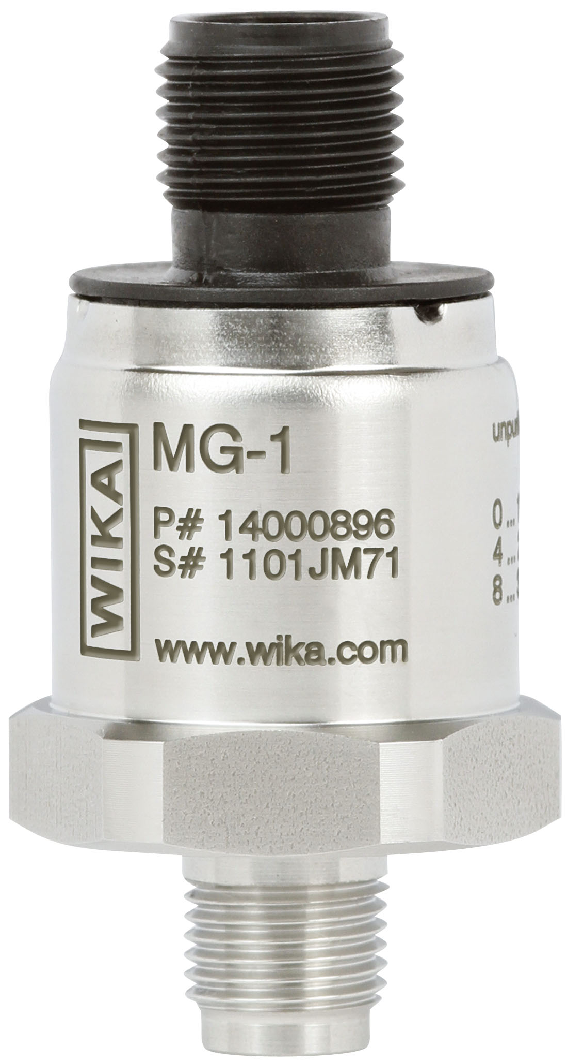

Edited by:
WIKA Alexander Wiegand SE & Co. KG
André Habel Nunes
Marketing Services
63911 Klingenberg, Germany
Tel +49 9372 · 132 - 806
Fax +49 9372 · 132 - 9803
E-Mail a.habel-nunes@wika.de
Internet www.wika.de

WIKA press release 04/2011

