A family of electronic switches for
pressure, temperature and level

Klingenberg, April 2011.
WIKA is presenting an innovative product family of electronic switches for fluid technology in machine building for the first time at the Hannover Messe. The new industrial instruments measure and control pressure, temperature and level with an identical "look and feel".

The switches have high functionality and are also very user-friendly. The three-key operation with tactile feedback and a clear menu structure ensure that commissioning is smooth and trouble-free. Set parameters can also be checked quickly.

The parameters and values are displayed on a 14-segment LED display with nine-millimetre high characters. In particular, readability of characters has been improved considerably to be more intuitive to work with. The display and housing rotates independently, making the parameters and values easy to read, even under difficult conditions. The design is as flexible as it is robust, and through the numerous possibilities for mounting and setting and the high ingress protection, it can be installed in virtually any environment.

The model PSD-30, TSD-30 and LSD-30 switches are available in various country-specific versions. Therefore they can be used worldwide.

Number of characters: 1267
Keywords: Electronic switch family

Manufacturer:
WIKA Alexander Wiegand SE & Co. KG
Alexander-Wiegand-Straße 30
63911 Klingenberg/Germany
Tel. (+49) 9372 132-0
Fax (+49) 9372 132-406
E-mail sales@wika.de
www.wika.de

WIKA company photograph:
Electronic switch family, models PSD-30, TSD-30 and LSD-30

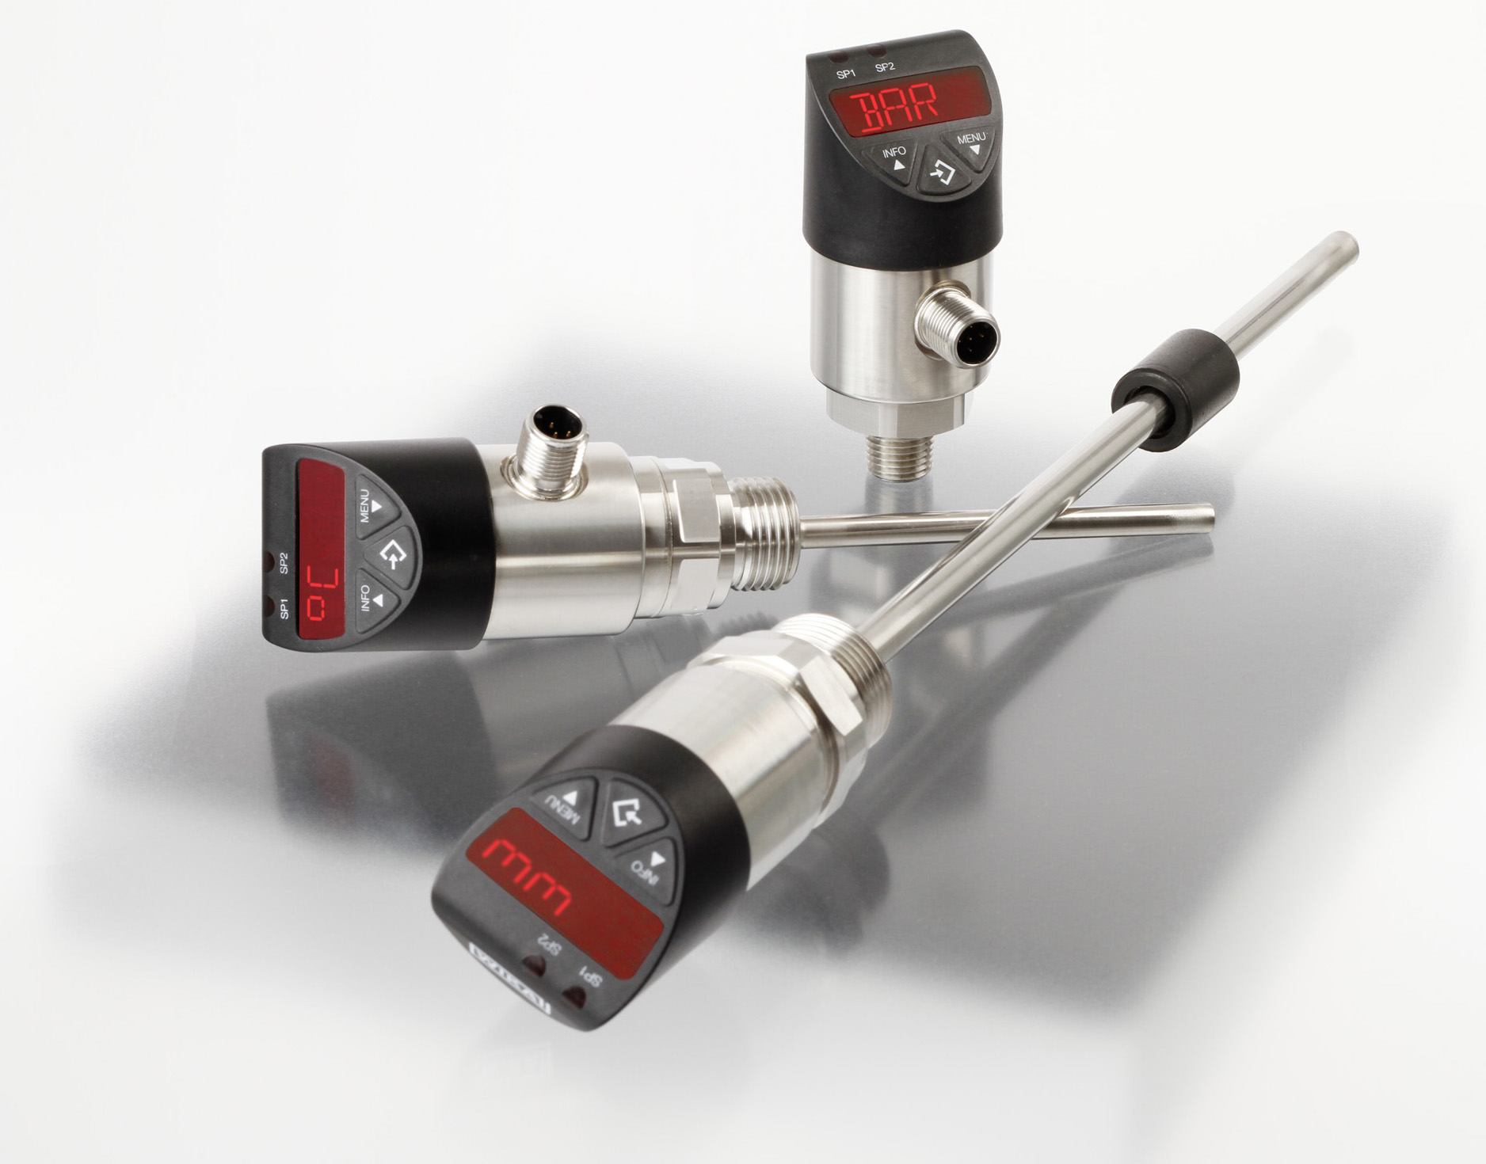

Edited by:
WIKA Alexander Wiegand SE & Co. KG
André Habel Nunes
Marketing Services
Alexander-Wiegand-Straße 30
63911 Klingenberg/Germany
Tel. (+49) 9372 132-806
Fax (+49) 9372 132-9803
E-mail a.habel-nunes@wika.de
www.wika.de

WIKA press release 05/2011

