Compact pressure gauge with dry
measuring cell for sanitary applications

Klingenberg, February 2012.
The diaphragm pressure gauge from WIKA has been designed for pressure measurement in hygienic processes such as those in sanitary applications. Unlike diaphragm seals, it uses a dry measuring cell. That means, if the diaphragm should leak, no system fill fluid escapes into the process. Thus the new model PG43SA pressure gauge increases process safety.

In addition to this, its design with a welded, flush diaphragm and surface roughnesses of ≤ 0.4 µm ensures very good cleanability. No deposits are left on the process connection. The entire measuring instrument can be steam-sterilised (autoclaved) at 134°C and is suitable for SIP/CIP processes.

By integrating the centre-back-mount process connection into the case a compact, robust and hygienic design of the pressure gauge is enabled. The instrument, available in nominal sizes of 40 and 63, is thus ideally suited for space-saving installation, harsh operating conditions and cleaning from outside.

Number of characters: 1053
Key words: Diaphragm pressure gauge PG43SA

Manufacturer:
WIKA Alexander Wiegand SE & Co. KG
Alexander-Wiegand-Straße
63911 Klingenberg
Tel +49 9372 · 132 – 0
Fax +49 9372 · 132 – 406
E-Mail Vertrieb@wika.de
Internet www.wika.com

WIKA company photograph:
WIKA diaphragm pressure gauge PG43SA

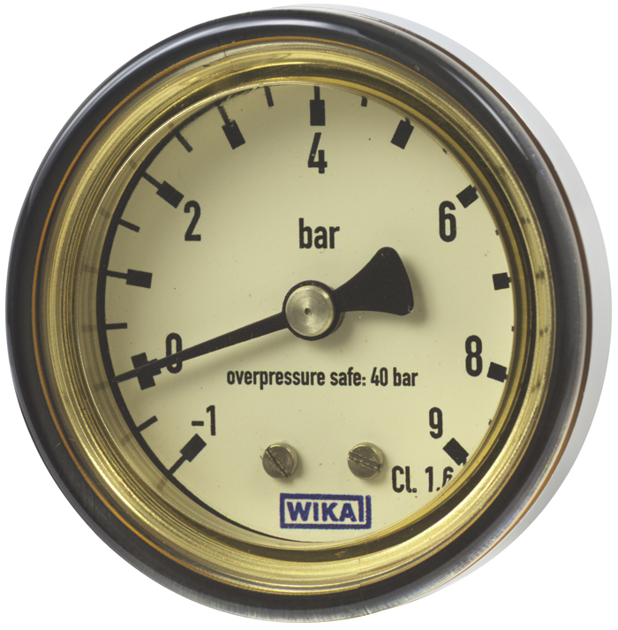

Edited by:
WIKA Alexander Wiegand SE & Co. KG
André Habel Nunes
Marketing Services
63911 Klingenberg
Tel +49 9372 · 132 - 8010
Fax +49 9372 · 132 - 8008010
E-Mail a.habel-nunes@wika.de
Internet www.wika.de

Press release 05/2012

