New process thermometer
with centrically spring-loaded, exchangeable measuring insert

Klingenberg, April 2011.
For "heavy-duty" applications, WIKA has developed a family of process thermometers which are notable for their innovative neck tube design with exchangeable measuring insert.

The TR12 resistance thermometer and the TC12 thermocouple are therefore particularly suitable for use in the process industry, in the chemical industry and in offshore applications. The centrically spring-loaded measuring insert and its extended spring travel enable combination with the widest range of connection head designs.

A process transmitter can also be fitted without difficulty. For mounting into the process there is a wide selection of WIKA thermowells to choose from.

Number of characters: 766
Key words: Process thermometer Tx12

Manufacturer:
WIKA Alexander Wiegand SE & Co. KG
Alexander-Wiegand-Straße 30
63911 Klingenberg/Germany
Tel. (+49) 9372 132-0
Fax (+49) 9372 132-406
E-mail sales@wika.de
www.wika.de

WIKA company photograph:
The new process thermometer with exchangeable measuring insert.
Example: TC12-B with TIF50 process transmitter

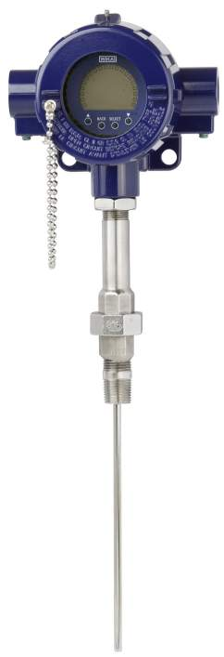

Edited by:
WIKA Alexander Wiegand SE & Co. KG
André Habel Nunes
Marketing Services
Alexander-Wiegand-Straße 30
63911 Klingenberg/Germany
Tel. (+49) 9372 132-806
Fax (+49) 9372 132-9803
E-mail a.habel-nunes@wika.de
www.wika.de

WIKA press release 06/2011

