Precision digital pressure gauge now with
ATEX approval and data logger
Klingenberg, April 2010.
With the CPG1000, WIKA offers a precision digital pressure gauge that has ATEX approval and an integrated data logger as standard.

With this, the robust and particularly easy-to-handle pressure gauge covers an exceptionally wide range of applications: Wherever high precision, extreme durability and the documentation of process data are required, this instrument, equally suited to testing and calibrating, offers the perfect on-site solution - even in hazardous areas.

With its integrated data logger, the CPG1000 enables the recording of relevant data in the field - and its transmission to a PC, with the help of the new CPGLog software. The recording interval can be individually configured. The process data can then be evaluated and documented on the PC.

With the CPG1000, if needed, a simultaneous recording of pressure and temperature values is even possible.

Number of characters: 965
Code word: CPG1000 with ATEX approval

Manufacturer:
WIKA Alexander Wiegand SE & Co. KG
Alexander-Wiegand-Strasse
D-63911 Klingenberg
Tel. +49 · 9372 · 132-0
Fax +49 · 9372 · 132-406
E-Mail sales@wika.de
Internet www.wika.de

WIKA company photograph:
CPG1000 precision digital pressure gauge

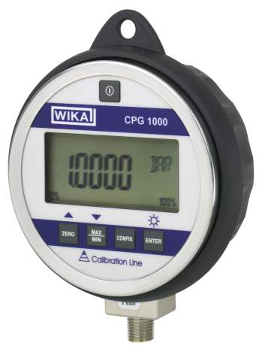

Edited by:
WIKA Alexander Wiegand SE & Co. KG
André Habel Nunes
Marketing Services
63911 Klingenberg, Germany
Tel +49 · 9372 · 132-806
Fax +49 · 9372 · 132-423
E-Mail a.habel-nunes@wika.de
Internet www.wika.de

WIKA press release 07/2010

