New thermowell:
Self-draining in any mounting position

Klingenberg, April 2010.
WIKA has developed a new thermowell for sanitary applications. The TW61 in hygienic design not only enables temperature measurement with the minimum of dead space, but also, at the same time, remains self-draining in all mounting positions.

The patent-pending design avoids the usual neck in the respective pipe section for fitting the measuring instrument. The new TW61 thermowell ensures simple cleaning and reduces the risk of contamination. The process connection is made via an orbital weld or via a removable hygienic connection.

In combination with the TR22 or the TR21 resistance thermometer the new thermowell represents a highly-efficient solution for temperature measuring points: Both thermometers increase the installation flexibility, either due to the rotatable connection head (TR22) or the exceptionally compact dimensions (TR21). In addition, the instruments can be calibrated, time- and cost-effectively, on-site, with a sealed process and without having to disconnect the electrical connections.

Number of characters: 1129
Code word: Thermowell TW61

Manufacturer:
WIKA Alexander Wiegand SE & Co. KG
Alexander-Wiegand-Strasse
D-63911 Klingenberg
Tel. +49 · 9372 · 132-0
Fax +49 · 9372 · 132-406
E-Mail sales@wika.de
Internet www.wika.de

WIKA company photograph:
TW61 themowell in combination with the TR22 resistance thermometer

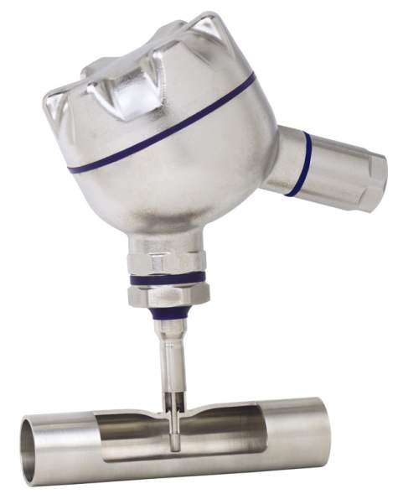

Edited by:
WIKA Alexander Wiegand SE & Co. KG
André Habel Nunes
Marketing Services
63911 Klingenberg, Germany
Tel +49 · 9372 · 132-806
Fax +49 · 9372 · 132-423
E-Mail a.habel-nunes@wika.de
Internet www.wika.de

WIKA press release 08/2010

