New differential pressure gauge
for refrigeration and air-conditioning applications

Klingenberg, October 2010.
For the requirements of the refrigeration and air-conditioning industry, WIKA has designed a new differential pressure gauge with an integrated temperature scale. The instrument from the 73x.18 series, which is also available as a duplex pressure gauge and has already been presented to the trade at CHILLVENTA, can be delivered in nominal sizes 80 and 100.

Through this multifunctional instrument, users get all important process data at a glance. Alongside the pressure on both the negative and the positive pressure side, the differential pressure can also be displayed at the same time on a third scale. Parallel to that, the model 73x.18 determines the vapour pressure and the resultant vapour temperature.

The new differential pressure gauge can be mounted in a number of ways (wall and mounting clamps, panel mounting) and is suitable for all common refrigerants. All wetted parts are made from stainless steel so that a long service life is guaranteed. For extreme loads, there is an additional variant available with liquid filling.

Number of characters: 1148
Key words: Differential pressure gauge 73x.18

Manufacturer:
WIKA Alexander Wiegand SE & Co. KG
Alexander-Wiegand-Straße
D-63911 Klingenberg
Tel +49 9372 132 – 0
Fax +49 9372 · 132 – 406
E-Mail sales@wika.de
Internet www.wika.de

WIKA company photograph:
New differential pressure gauge 73x.18

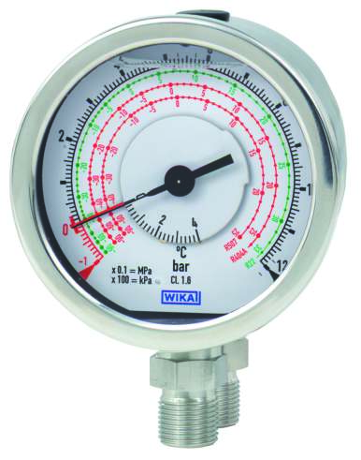

Edited by:
WIKA Alexander Wiegand SE & Co. KG
André Habel Nunes
Marketing Services
63911 Klingenberg, Germany
Tel + 9372 · 132 - 806
Fax + 9372 · 132 - 9803
E-Mail a.habel-nunes@wika.de
Internet www.wika.de

WIKA press release 09/2010

