WIKA presents a brochure
for refrigeration and air-conditioning applications

Klingenberg, October 2010.
On the occasion of CHILLVENTA, WIKA has launched a new information brochure for manufacturers of refrigeration and air-conditioning equipment. In the 24-page booklet, the company presents its comprehensive, industry-specific range of instruments for pressure and temperature measurement.

With reference to several application examples, such as "compressors" and “liquid-cooled condensers and evaporators", WIKA has documented its broad product portfolio. A variety of materials, components, process connections and safety standards enable tailored solutions for both domestic and international markets. Moreover, for control systems and solutions, WIKA has developed a new, mechatronic product line. There is even a calibration service on offer for operators of refrigeration and air-conditioning plants, which is also available on site.

The new WIKA brochure can be ordered as a hard copy from the website, www.wika.com, or downloaded as a PDF file (under "Downloads").

Number of characters:
Key words: Brochure "Refrigeration and air-conditioning technology"

Manufacturer:
WIKA Alexander Wiegand SE & Co. KG
Alexander-Wiegand-Straße
D-63911 Klingenberg
Tel +49 9372 132 – 0
Fax +49 9372 · 132 – 406
E-Mail sales@wika.de
Internet www.wika.de

WIKA company photograph:
New WIKA brochure "Refrigeration and air-conditioning technology"

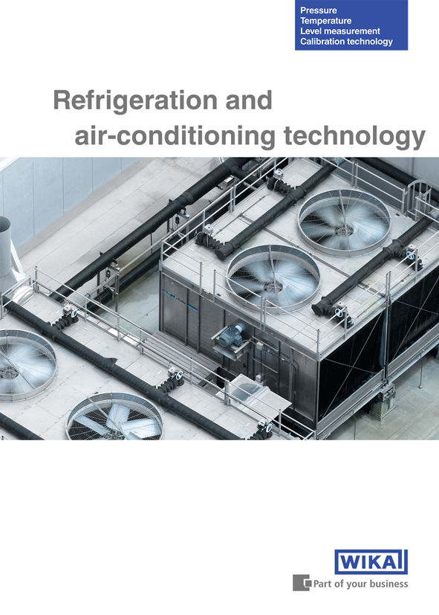

Edited by:
WIKA Alexander Wiegand SE & Co. KG
André Habel Nunes
Marketing Services
63911 Klingenberg, Germany
Tel +49 9372 · 132 - 806
Fax +49 9372 · 132 - 9803
E-Mail a.habel-nunes@wika.de
Internet www.wika.de

WIKA press release 10/2010

