New brochure: WIKA solutions
for water and wastewater applications

Klingenberg, October 2010.
With their new information brochure, WIKA put themselves forward as a competent partner for the major market of water and wastewater technology.
Alongside current solutions for pressure and temperature monitoring in water withdrawal and treatment plants, as well as in wastewater and process water systems, the 28-page brochure also offers an overview of the situation and the perspectives of global water supply.
The growing importance of drinking water from the sea is of equal significance as the use of process water or the production of ultrapure water for industrial plants.
The brochure can be downloaded from the company's website, www.wika.de, or ordered via e-mail through info@wika.de.

Number of characters: 790
Key words: WIKA brochure "Water & Wastewater Technology“

Issuer:
WIKA Alexander Wiegand SE & Co. KG
Alexander-Wiegand-Straße
D-63911 Klingenberg
Tel +49 9372 132 – 0
Fax +49 9372 · 132 – 406
E-mail sales@wika.de
Internet www.wika.de

WIKA company photograph:

Title of the brochure "Water & Wastewater Technology"

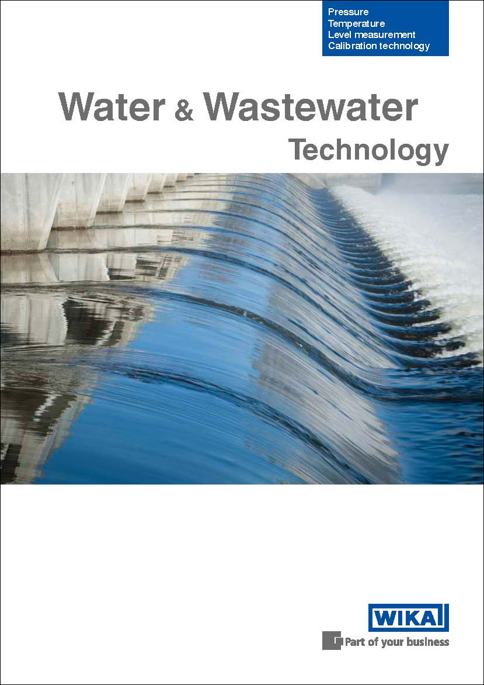

Edited by:
WIKA Alexander Wiegand SE & Co. KG
André Habel Nunes
Marketing Services
63911 Klingenberg, Germany
Tel +49 9372 · 132 - 806
Fax +49 9372 · 132 - 9803
E-Mail a.habel-nunes@wika.de
Internet www.wika.de

Press release 11/2010

