WIKA innovation:
Magnetic fast connector replaces crocodile clip

Klingenberg, November 2010.
WIKA has developed a magnetic fast connector that simplifies the configuration and calibration of pressure and temperature transmitters. The patented "magWIK" guarantees a quick connection and at the same time prevents the contacts from slipping off. With this, WIKA is the only company to offer a viable alternative to solutions with crocodile clips.

This innovative accessory is suitable for plug connectors of Ø 2 mm. The fast connector is easy to use, even under difficult operating and installation conditions. It enables a stable connection for configuration via HART, FF, PROFIBUS and proprietary protocols.

The "magWIK" has a robust design with unbreakable insulation. The connection contacts of the transmitter output are made via a magnetic coupling. This coupling can be easily separated. Thus the appropriate terminals can also be connected one after the other, or connected to separated points.

The new fast connector is available on its own. It can also be ordered together with a transmitter or a calibration instrument.

Number of characters: 1125
Key word: Magnetic fast connector "magWIK"

Manufacturer:
WIKA Alexander Wiegand SE & Co. KG
Alexander-Wiegand-Straße
D-63911 Klingenberg
Tel +49 9372 132 – 0
Fax +49 9372 · 132 – 406
E-Mail sales@wika.de
Internet www.wika.de

WIKA company photograph:
Magnetic fast connector "magWIK"

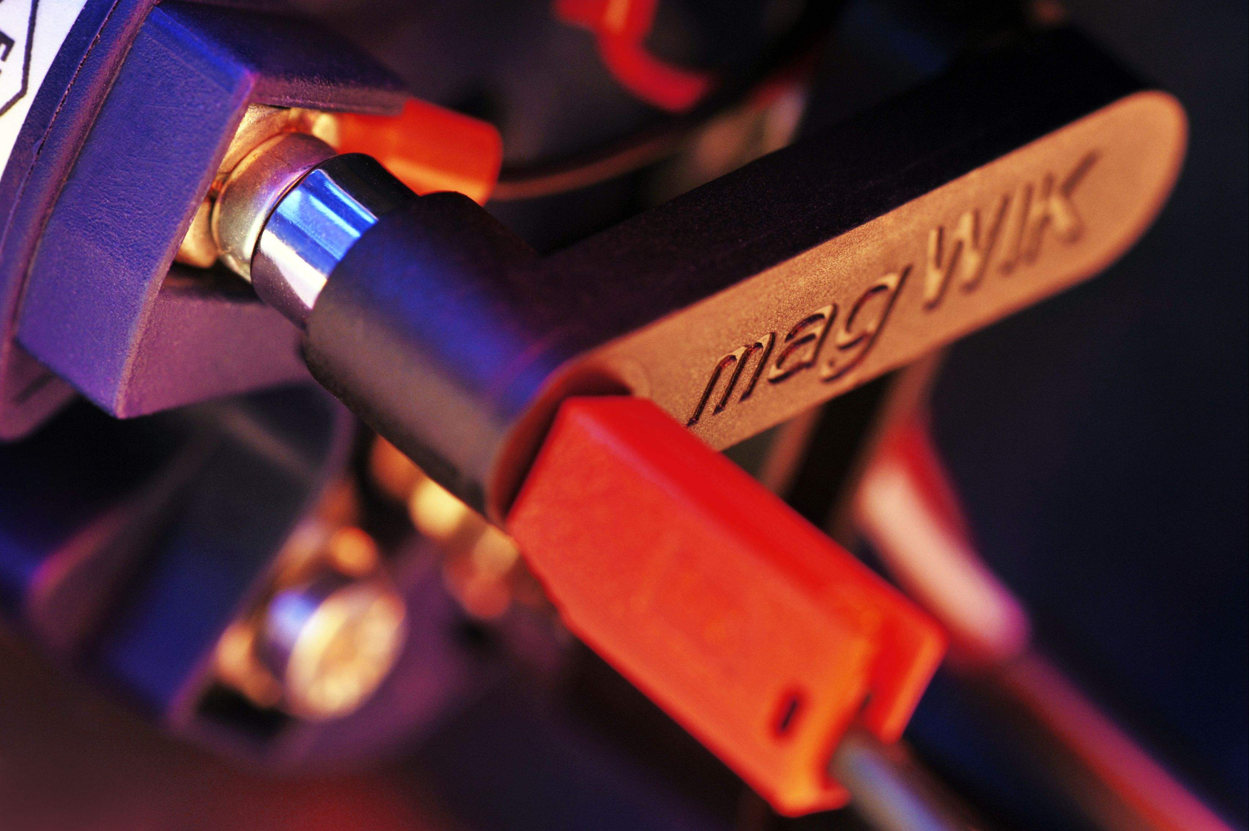

Edited by:
WIKA Alexander Wiegand SE & Co. KG
André Habel Nunes
Marketing Services
63911 Klingenberg, Germany
Tel +49 9372 · 132 - 806
Fax +49 9372 · 132 - 423
E-Mail a.habel-nunes@wika.de
Internet www.wika.de

WIKA press release 12/2010

