New calculation tool for thermowells

Klingenberg, December 2010.
The calculation of thermowells for temperature measuring points will be made on a new basis from this year on, and will therefore need an updated program. WIKA already offers such a tool on its website, free-of-charge.

The company is a member of the ASME "Performance Test Codes 19.3" working group and has contributed to the new ASME PTC 19.3 TW-2010 standard. Against this background WIKA now presents a calculation program built around the completely-overhauled standard, which enables significant improvements in respect of flexibility and safety.

Among other things, the new program takes into account the widest range of thermowell designs as well as the multidimensional vibration excitation of the thermowell due to the Kármán vortex street. The program, based around Excel, will be sent once you have registered at www.wika.com .

Number of characters: 900
Key word: Calculation tool for thermowells

Manufacturer:
WIKA Alexander Wiegand SE & Co. KG
Alexander-Wiegand-Straße
D-63911 Klingenberg
Tel +49 9372 132 – 0
Fax +49 9372 · 132 – 406
E-Mail sales@wika.de
Internet www.wika.de

WIKA company photograph:
Graphic chart of thermowell calculation for temperature measuring points

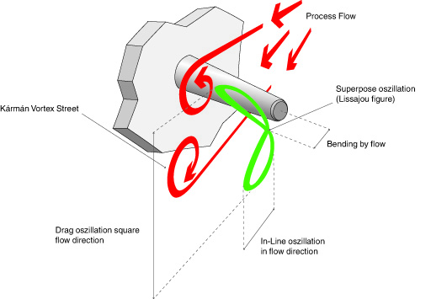

Edited by:
WIKA Alexander Wiegand SE & Co. KG
André Habel Nunes
Marketing Services
63911 Klingenberg, Germany
Tel +49 9372 · 132 - 806
Fax + 09372 · 132 - 9803
E-Mail a.habel-nunes@wika.de
Internet www.wika.de

WIKA press release 13/2010

