Isolated barrier
completes “Ex i” package
Klingenberg, February 2016.
The isolated barrier model IS Barrier completes WIKA's range of intrinsically safe products. The barrier is suitable for installation in zone 2 and is compatible with all corresponding transmitters from WIKA.

For use in hazardous areas, intrinsically safe transmitters require a barrier. It galvanically isolates the circuit between Ex and non-Ex areas. The model IS Barrier supplies sensors, depending on two- or four-wire system, via a power-supplying and non-power-supplying 0/4...20 mA input and also supports transmission of a HART® protocol. The current output can be operated actively or passively. The functional safety of the instrument is confirmed by the approval for SIL 2 applications.

In this way, WIKA offers a complete “Ex i” package: In addition to the sensor and barrier, it includes the matching cables and a form containing the data for the verification of intrinsic safety prescribed by law.

Number of characters: 910
Key words: Isolated barrier

Manufacturer:
WIKA Alexander Wiegand SE & Co. KG
Alexander-Wiegand-Straße 30
63911 Klingenberg/Germany
Tel. +49 9372 132-0
Fax +49 9372 132-406
vertrieb@wika.com
www.wika.de

WIKA company photograph:
WIKA isolated barrier model IS Barrier

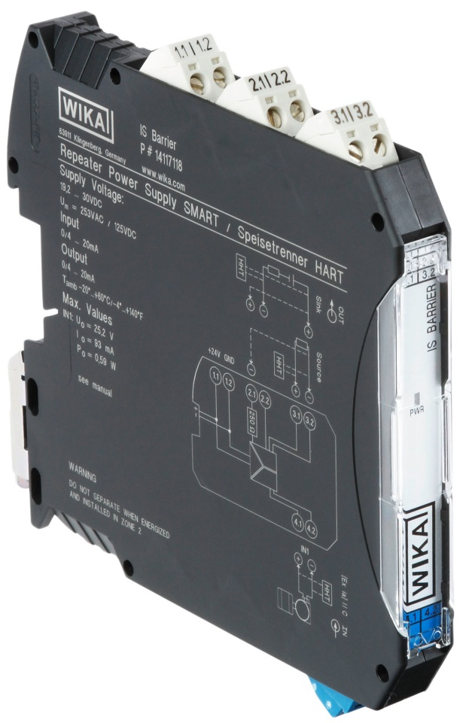

Edited by:
WIKA Alexander Wiegand SE & Co. KG
André Habel Nunes
Marketing Services
Alexander-Wiegand-Straße 30
63911 Klingenberg/Germany
Tel. +49 9372 132-8010
Fax +49 9372 132-8008010
andre.habel-nunes@wika.com
www.wika.de

WIKA press release 01/2016

