Miniature thermometer
explosion-protected for the first time

Klingenberg, March 2013.
For customers in industry, WIKA is making available a miniature electrical resistance thermometer with explosion protection - for the first time ever. The instrument belongs to the new "compact class" with digital transmitter, which is characterised by individual programmability alongside extreme toughness.

With the miniature thermometer models TR33 (standard version) and TR34 (Ex version) it is possible to cover a temperature range of -50 ... +250 °C. Newly developed software enables individual and user-friendly programming of the built-in transmitter.

The basis for the high performance of the resistance thermometers is their robust construction and their manufacture from high-quality materials. Both instruments offer a high resistance to vibration (20 g) and are immune to environmental influences with an ingress protection of IP 67 and IP 69K respectively. The intrinsically safe design of the TR34 is usable globally due to its international Ex approvals.

Number of characters: 1051
Key word: TR33/TR34

Manufacturer:
WIKA Alexander Wiegand SE & Co. KG
Alexander-Wiegand-Straße 30
63911 Klingenberg/Germany
Tel. +49 (0)9372 1320
Fax +49 (0)9372 132406
sales@wika.de
www.wika.com

WIKA company photograph:
Miniature thermometers
TR33 (standard version) and TR34 (with Ex approvals)

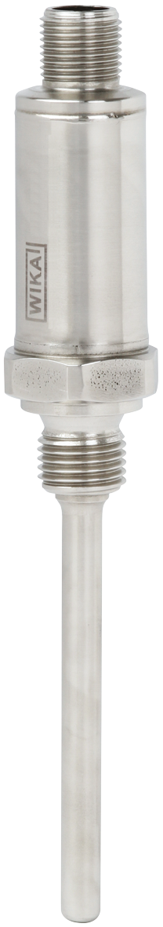

Edited by:
WIKA Alexander Wiegand SE & Co. KG
André Habel Nunes
Marketing Services
Alexander-Wiegand-Straße 30
63911 Klingenberg/Germany
Tel. +49 (0)9372 132-8010
Fax +49 (0)9372 132-8008010
andre.habel-nunes@wika.com
www.wika.com

WIKA press release 02/2013

