Superior pressure transmitter S-20:
Versatile and robust

Klingenberg, April 2013.
Extraordinary variety, high accuracy and robust design – these are the main features of the model S-20 pressure sensor that WIKA is now launching.

The new instrument has been designed for a wide range of applications and demanding measuring requirements. It offers continuous measuring ranges between 0 ... 0.4 and 0 ... 1,600 bar, which can be combined with all state-of-the-art output signals, process connections and electrical connections.

As an option, the model S-20 is available with different accuracy classes (0.125 %, 0.25 % and 0.5 % BFSL), extended temperature ranges and customer-specific pin assignments. Even under the most adverse conditions, the new pressure transmitter delivers accurate results.

There are very short lead times for all variants of the S-20. This new instrument is the further evolution of the proven S-10.

Number of characters: 919
Key word: S-20

Manufacturer:
WIKA Alexander Wiegand SE & Co. KG
Alexander-Wiegand-Straße 30
63911 Klingenberg/Germany
Tel. +49 (0)9372 1320
Fax +49 (0)9372 132406
vertrieb@wika.com
www.wika.com

WIKA company photograph:
WIKA pressure transmitter S-20

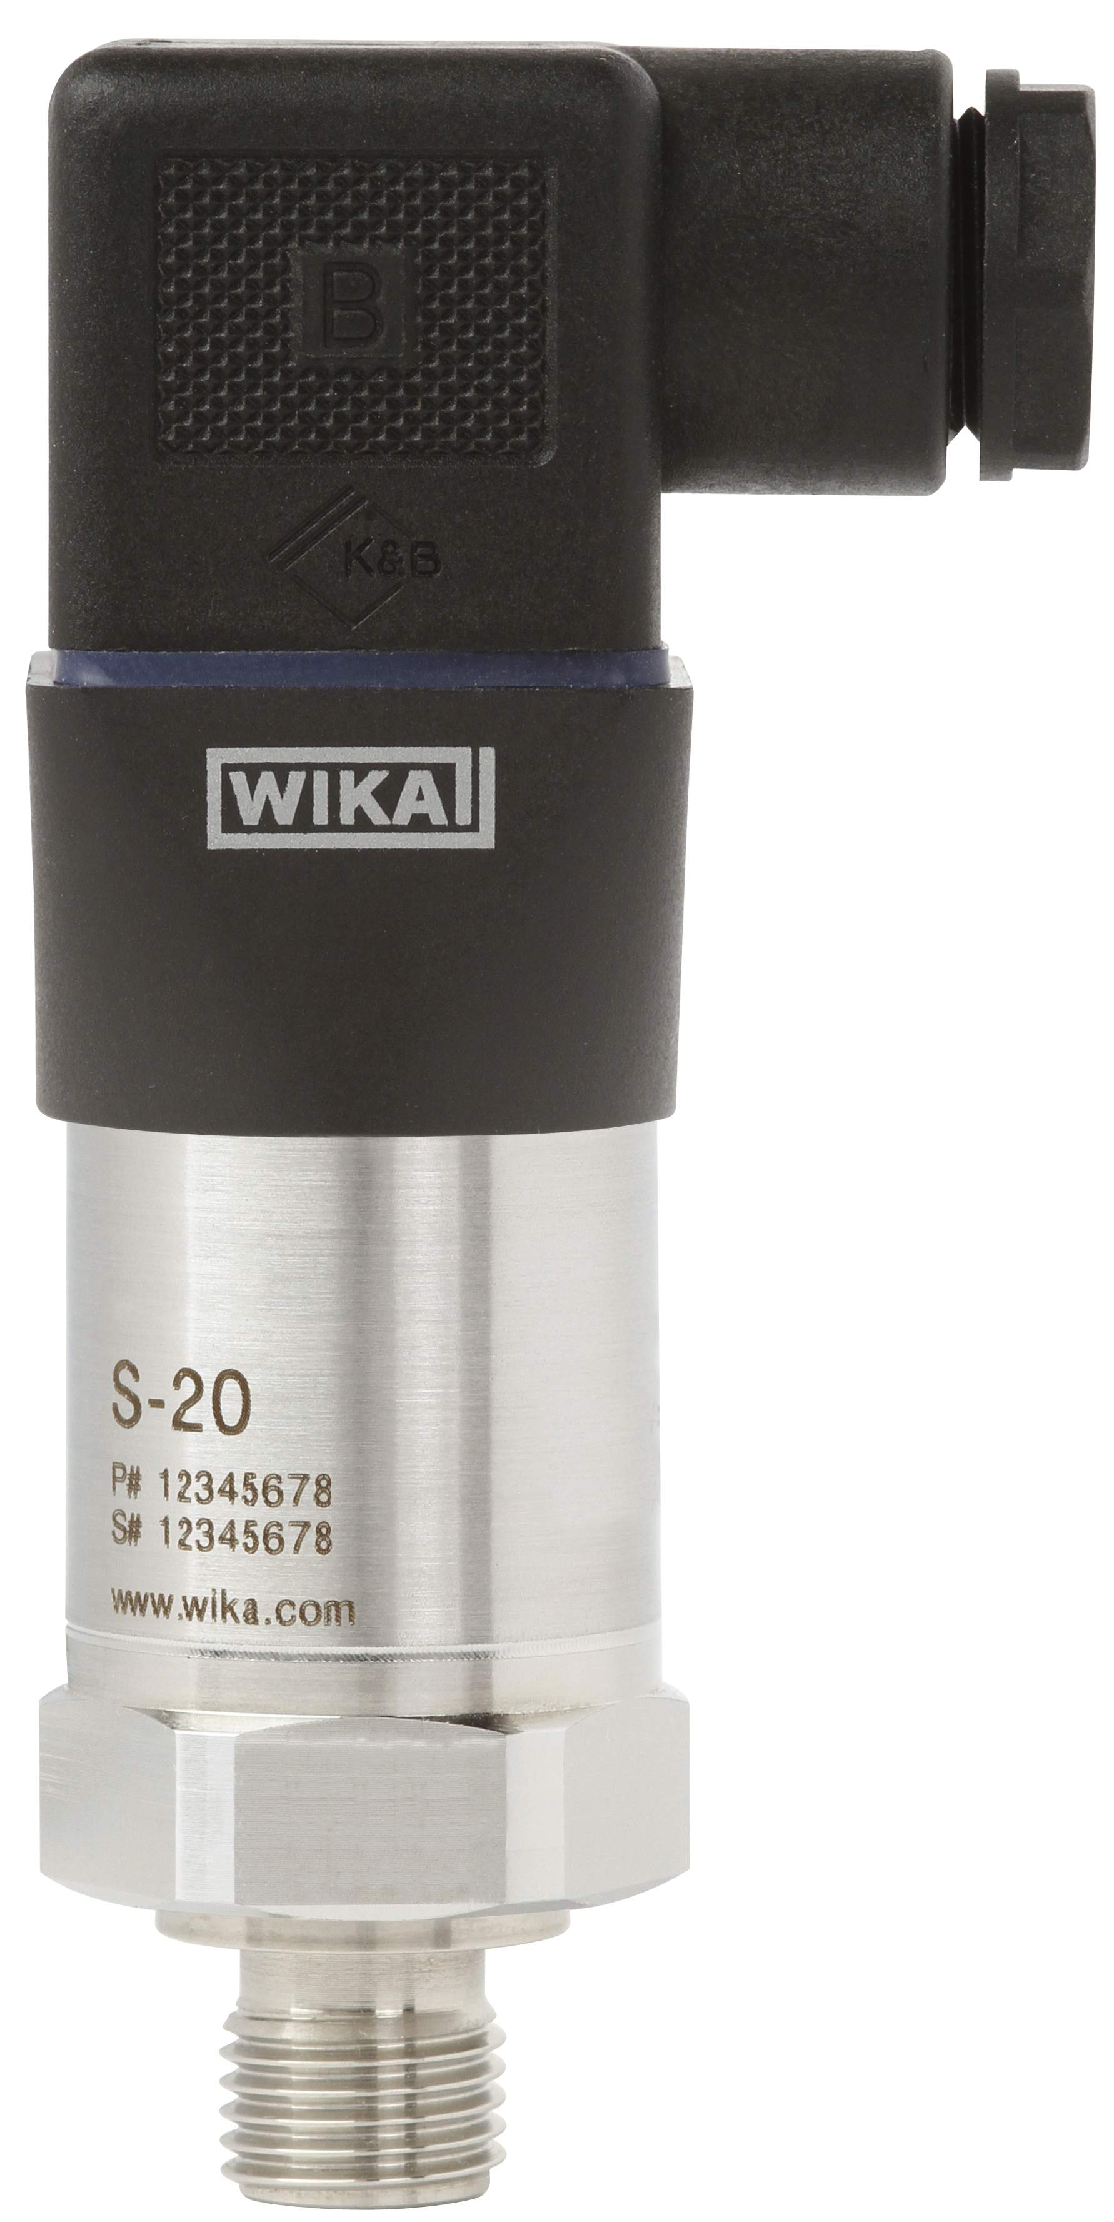

Edited by:
WIKA Alexander Wiegand SE & Co. KG
André Habel Nunes
Marketing Services
Alexander-Wiegand-Straße 30
63911 Klingenberg/Germany
Tel. +49 (0)9372 132-8010
Fax +49 (0)9372 132-8008010
andre.habel-nunes@wika.com
www.wika.com

WIKA press release 06/2013

