New pressure balances are
very easy to use
Klingenberg, March 2012.
WIKA has expanded its product portfolio in calibration technology with two new pressure balances. The CPB3800 has been designed for cost-conscious markets, while the CPB5800 has been developed for high-end customers. The new instruments are a further development of the previous CPB range from WIKA and the 580 series from DH-Budenberg, which has been part of the WIKA Group since 2011.

The CPB5800 delivers an accuracy of up to 0.006 %. The dual-range piston-cylinder system with automatic measuring range changing, developed by DH-Budenberg, is integrated in the new dead weight tester. This provides an even wider range of applications without any additional equipment changes.

With the CPB5800, customers can access a wide selection of measuring ranges, pressure units and transmission fluids. For ease of use, the integrated priming pump and the patented ConTect quick-release system contribute towards the tool-free changing of the piston-cylinder system.

Due to its compact base and low weight, the model CPB3800 is primarily suited to on-site maintenance and service applications. The simple-to-use dead weight tester covers measuring ranges of up to 1,200 bar with an accuracy of up to 0.025%.

Number of characters: 1267
Key words: CPB3800 and CPB5800

Manufacturer:
WIKA Alexander Wiegand SE & Co. KG
Alexander-Wiegand-Straße 30
63911 Klingenberg/Germany
Tel. +49 (0)9372 1320
Fax +49 (0)9372 132406
Vertrieb@wika.de
www.wika.de

WIKA company photograph:
CPB5800 dead weight tester

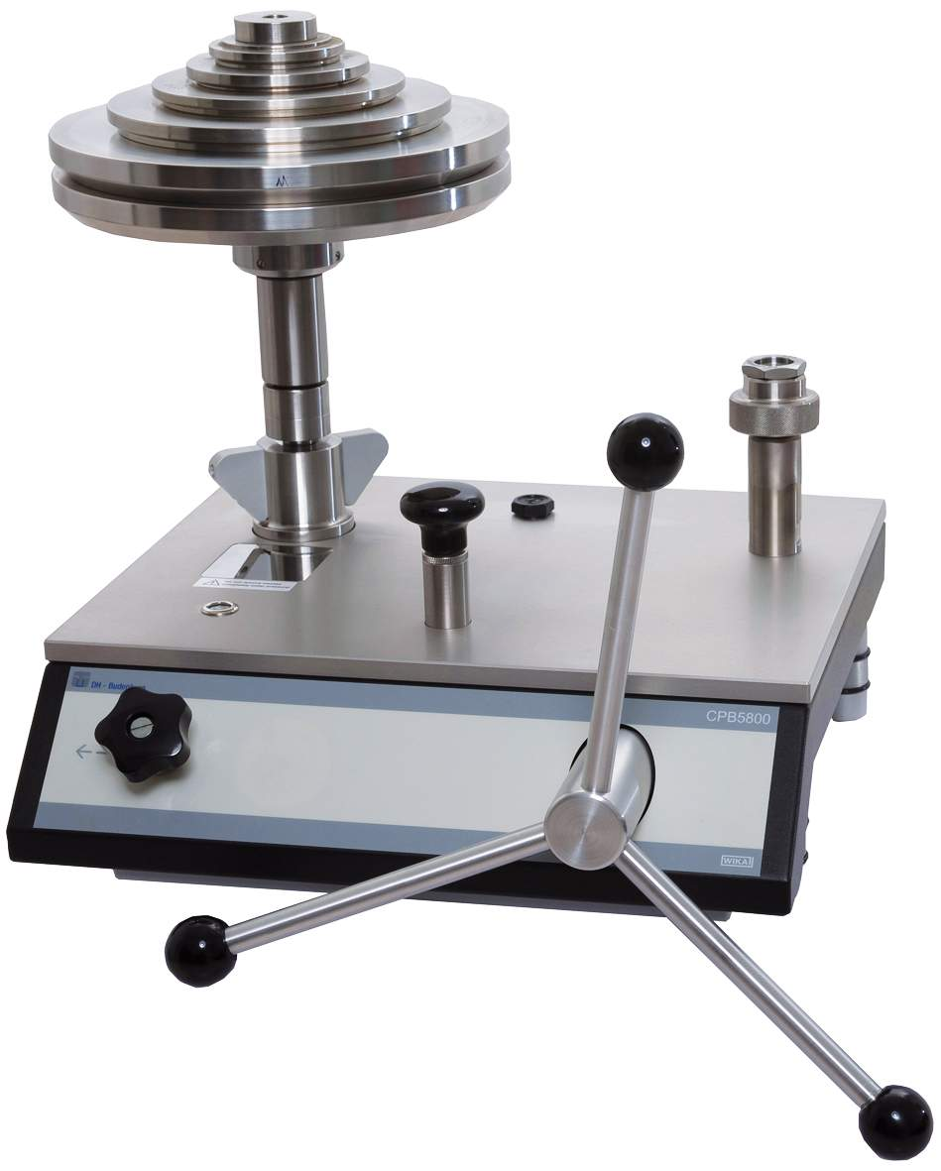

Edited by:
WIKA Alexander Wiegand SE & Co. KG
André Habel Nunes
Marketing Services
Alexander-Wiegand-Straße 30
63911 Klingenberg/Germany
Tel. +49 (0)9372 132-8010
Fax +49 (0)9372 132-8008010
a.habel-nunes@wika.de
www.wika.de

WIKA press release 08/2012

