OEM pressure transmitter:
Resistant to overload and condensation

Klingenberg, Juli 2013.
WIKA now offers new options with their O-10 OEM pressure transmitter. Under the model designation O-10 (5), the instrument is available with a five-fold overpressure safety and resistance to condensation.

The overload capacity is mainly aimed at applications in the market segments of water supply and irrigation systems. It protects the pressure sensor from possible damage from the water-hammer effect that fast-switching valves can cause.

Furthermore, in the future, the O-10, developed for the global market, will also be available with a condensation-resistant housing. This prevents the formation of condensation in the instrument, which can occur where there is a distinct difference between the fluid and the ambient temperature.

These options increase the durability, and thus the service life, of the O-10 pressure sensor in critical applications.

Number of characters: 940
Key words: Pressure transmitter O-10 (5)

Manufacturer:
WIKA Alexander Wiegand SE & Co. KG
Alexander-Wiegand-Straße 30
63911 Klingenberg/Germany
Tel. +49 9372 132-0
Fax +49 9372 132-406
sales@wika.de
www.wika.de

WIKA company photograph:
OEM pressure transmitter O-10 (5)

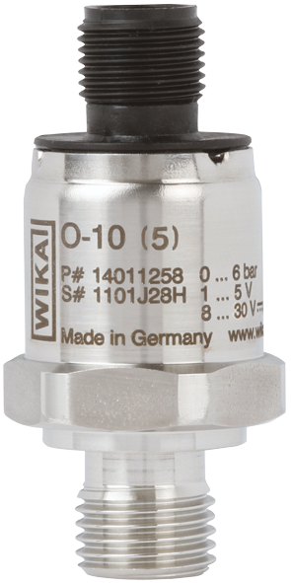

Edited by:
WIKA Alexander Wiegand SE & Co. KG
André Habel Nunes
Marketing Services
Alexander-Wiegand-Straße 30
63911 Klingenberg/Germany
Tel. +49 9372 132-8010
Fax +49 9372 132-8008010
andre.habel-nunes@wika.com
www.wika.de

WIKA press release 08/2013

