New "cULus" test mark for
WIKA A-10 pressure transmitter

Klingenberg, May 2011.
The new test mark "cULus listed" attests that the WIKA A-10 pressure transmitter now has certification for the entire North American market.

Since 1st April, 2011 the new mark, "cULus listed", brings together the previous UL (Underwriter Laboratories/USA) and CSA (Canadian Standards Association) test marks. The combined test mark confirms that the samples tested by the independent US notified body (UL) meet the recognised US American and also the Canadian standards with respect to safety and performance.
Through the unified certification, the WIKA A-10 recommends itself particularly for those European machine and plant builders serving the whole North American market. The A-10 is an exceptionally compact, multi-purpose pressure transmitter with an extremely low failure probability and outstanding value for money.

Number of characters: 989
Key words: A-10 with new test mark

Manufacturer:
WIKA Alexander Wiegand SE & Co. KG
Alexander-Wiegand-Straße 30
63911 Klingenberg/Germany
Tel. (+49) 9372 132-0
Fax (+49) 9372 132-406
E-mail sales@wika.de
www.wika.com

WIKA company photograph:
With the new test mark, "cULus listed", certified for the entire North American market:
WIKA A-10 pressure transmitter.

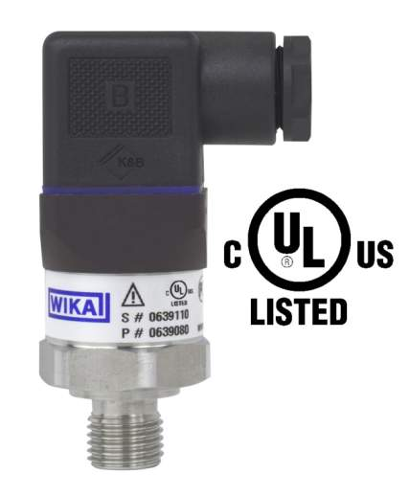

Edited by:
WIKA Alexander Wiegand SE & Co. KG
André Habel Nunes
Marketing Services
Alexander-Wiegand-Straße 30
63911 Klingenberg/Germany
Tel. (+49) 9372 132-8010
Fax (+49) 9372 132-8008010
E-mail a.habel-nunes@wika.de
www.wika.de

WIKA press release 09/2011

