air2guide: Measuring instruments for ventilation and air-conditioning - with a new design

Klingenberg, April 2012.
WIKA has expanded and optimised its successful air2guide range of measuring instruments for ventilation and air-conditioning applications and is now launching it in a new design.

The complete product family, which was introduced in 2008, now gets a modern and uniform image. At the same time, WIKA has expanded its capacity, in order to meet the growing demand for air2guide instruments - quickly and with the usual delivery quality. Furthermore, the technology has been constantly optimised in all measuring instruments, and new products have been added to the portfolio.

Users profit with air2guide - not only from the measurement precision - but especially from the uncomplicated and time-saving operation: Installation can be made without tools. Initial installation or instrument replacement only takes half the time as for conventional models.

The extensive range has been developed on the basis of a sound investigation of the market's and customers' needs. From the differential pressure switch for filter monitoring to the air quality sensor, it provides solutions for all segments in ventilation and air-conditioning technology.

Number of characters: 1251
Key word: air2guide

Manufacturer:
WIKA Alexander Wiegand SE & Co. KG
Alexander-Wiegand-Straße 30
63911 Klingenberg/Germany
Tel. (+49) 9372 132-0
Fax (+49) 9372 132-406
E-Mail sales@wika.de
www.wika.com

WIKA company photograph:
air2guide measuring instruments for ventilation and air-conditioning

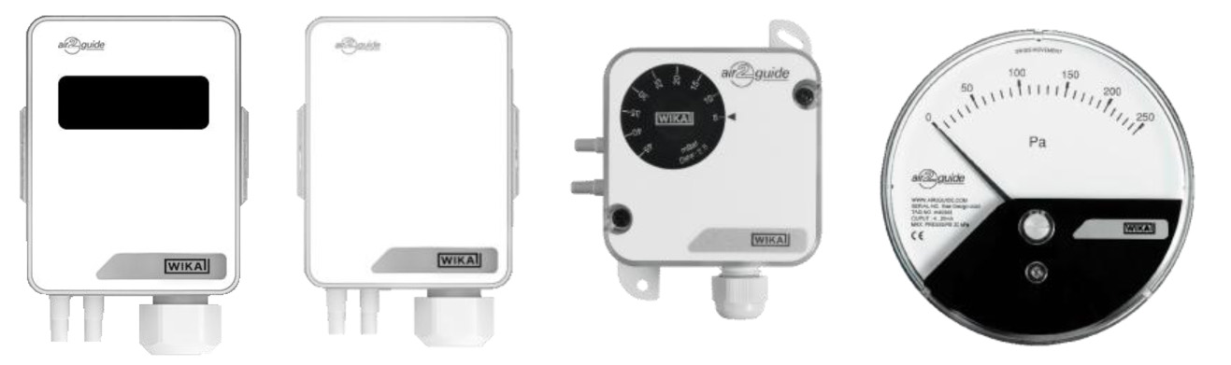

Edited by:
WIKA Alexander Wiegand SE & Co. KG
André Habel Nunes
Marketing Services
Alexander-Wiegand-Straße 30
63911 Klingenberg/Germany
Tel. (+49) 9372 132-8010
Fax (+49) 9372 132-8029
E-Mail a.habel-nunes@wika.de
www.wika.com

WIKA press release 09/2012

