Pressure transmitter A-10
now also in block design

Klingenberg, März 2015.
The A-10 pressure transmitter is now also available in a block design. This particularly robust variant of the all-round instrument is especially suited to shipbuilding applications.

In the block design version, the A-10 is flanged, and not installed using the threads, as is usually done. There are two through-holes available for fastening. The pressure adaption is made either via a flange connection or a G 1/4 female thread.

Since last year, the A-10 has held a GL approval (Germanischer Lloyd) for use in offshore applications. This certificate is now also valid for the block design.

Number of characters: 588
Key words: A-10 in block design

Manufacturer:
WIKA Alexander Wiegand SE & Co. KG
Alexander-Wiegand-Straße 30
63911 Klingenberg/Germany
Tel. +49 9372 132-0
Fax: +49 9372 132-406
vertrieb@wika.com
www.wika.com

WIKA company photographs:
Pressure transmitter A-10 in block design

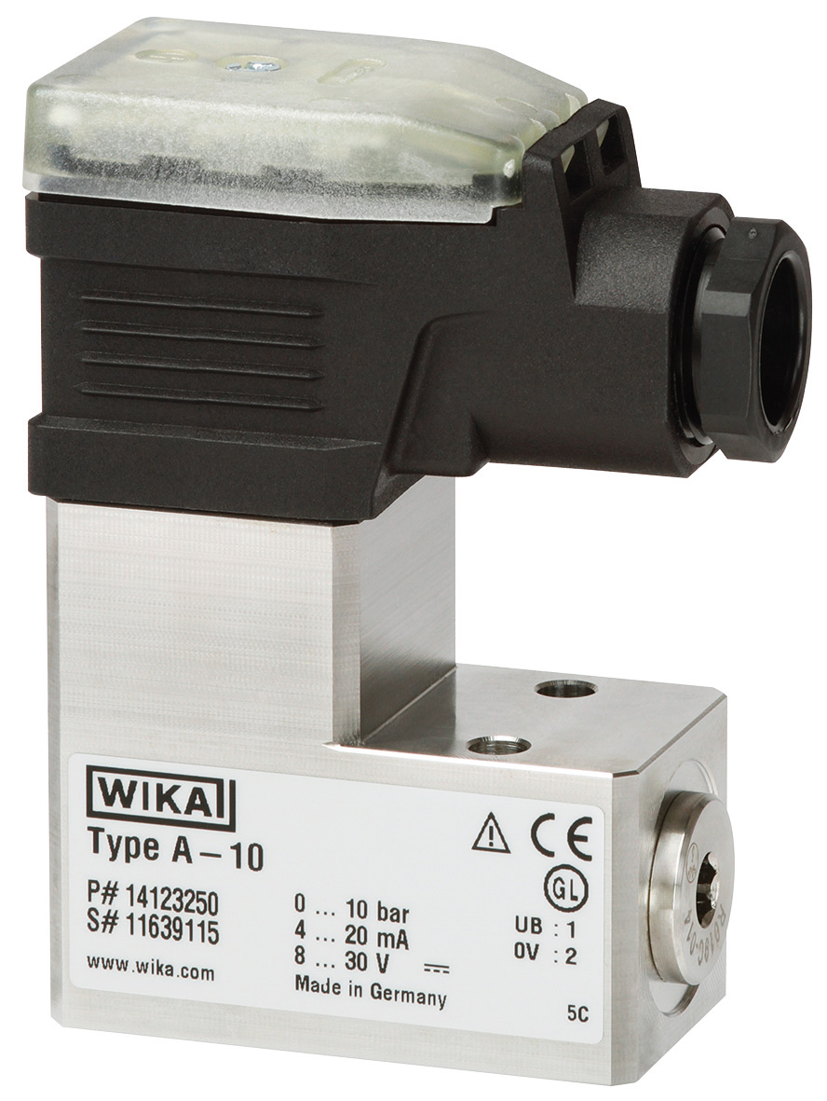

Edited by:
WIKA Alexander Wiegand SE & Co. KG
André Habel Nunes
Marketing Services
Alexander-Wiegand-Straße 30
63911 Klingenberg/Germany
Tel. +49 9372 132-8010
Fax: +49 9372 132-8008010
andre.habel-nunes@wika.com
www.wika.com

WIKA press release 09/2015

