New pressure transmitter
for the global OEM market

Klingenberg, August 2011.
Wika has designed its new O-10 pressure transmitter for industrial applications anywhere in the world. As a result of its specification, performance and price, it is especially suited for customers with high volume requirements.

The O-10 works with a measuring range of 0 ... 6 to 0 ... 600 bar. A wide choice of pressure connections, electrical connections (including the popular DIN-A) and output signals guarantee the widest range of applications. In order to further ease entry into international markets,
both North American and Russian approvals have been applied for the O-10.

With this new pressure transmitter WIKA is aiming mainly at manufacturers of pumps, compressors and hydraulic systems who have an annual requirement of more than 1,000 instruments of identical specification. The minimum delivery quantity is 50 pieces.

If required, the O-10 can be ordered with the customer's own company logo and model designation.

Number of characters: 1003
Key words: Pressure transmitter O-10

Manufacturer:
WIKA Alexander Wiegand SE & Co. KG
Alexander-Wiegand-Straße 30
63911 Klingenberg/Germany
Tel. (+49) 9372 132-0
Fax (+49) 9372 132-406
E-mail sales@wika.de
www.wika.de

WIKA company photograph:
Pressure transmitter O-10

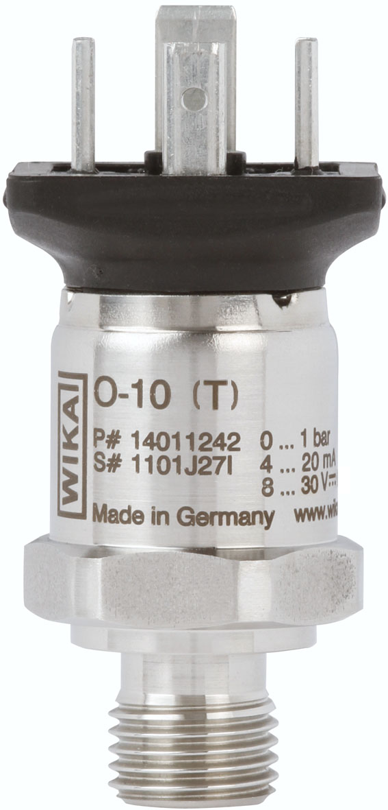

Edited by:
WIKA Alexander Wiegand SE & Co. KG
André Habel Nunes
Marketing Services
Alexander-Wiegand-Straße 30
63911 Klingenberg/Germany
Tel. (+49) 9372 132-806
Fax (+49) 9372 132-9803
E-mail a.habel-nunes@wika.de
www.wika.com

WIKA press release 10/2011

