SF₆ gas: New transmitters
for proactive plant monitoring

Klingenberg, October 2013.
Two new transmitters from WIKA provide the foundation for continuous, digital monitoring of the quenching and insulating gas sulphur hexafluoride (SF₆). The models GDT-20 and
GDHT-20, with their MODBUS® signal, give a clear indication of the SF₆ condition of gas-insulated equipment and thus enable maintenance to be planned solely on demand.

Based on precise pressure and temperature measurement, the two new transmitters constantly calculate the density of the SF₆. Thus, even the smallest leaks are identified at an early stage. The model GDHT-20 also measures the gas humidity, so that the formation of corrosive decomposition products can be prevented. If the equipment is filled with SF₆ gas mixtures, such as SF₆/N₂ or SF₆/CF₄, both instruments can be configured by the customer.

The continuous monitoring of SF₆ from the control room gives the foundation for condition-based, and thus cost-optimised, equipment maintenance. The digitised measuring process brings a further advantage: By using the standard MODBUS® RTU protocol, the data of up to 247 instruments can be retrieved from a single master. In this way, the costs for wiring and implementation are significantly reduced in comparison with analogue technology.

Number of characters: 1311
Key words: GDT-20 and GDHT-20

Manufacturer:
WIKA Alexander Wiegand SE & Co. KG
Alexander-Wiegand-Straße 30
63911 Klingenberg/Germany
Tel. +49 9372 1320
Fax +49 9372 132406
sf6-sales@wika.com
www.wika.com/sf6

WIKA company photograph:
GDT-20 (left) and GDHT-20 (right)

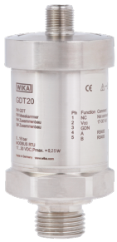
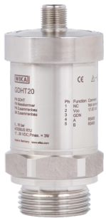

Edited by:
WIKA Alexander Wiegand SE & Co. KG
André Habel Nunes
Marketing Services
Alexander-Wiegand-Straße 30
63911 Klingenberg/Germany
Phone +49 9372 132-8010
Fax +49 9372 132-8008010
andre.habel-nunes@wika.com
www.wika.com

WIKA press release 13/2013

