Electronic switches, now with IO-Link revision V1.1

Klingenberg, May 2015.
WIKA's electronic switches now come with the option of IO-Link V1.1. This enables instruments for pressure and temperature measurement to be used even more efficiently.

Via IO-Link interface, the switches communicate with a master via a point-to-point connection. All parameters, process data and diagnostics information are transmitted over the sensor cable. Sensor parameters are stored in the master and can be altered during operation. When an instrument is replaced, its stored configuration is retrieved from the master via IO-Link. Thus, there is no need for an expensive and time-consuming initial set-up for the new sensor.

IO-Link strengthens the high functionality and ease-of-use of the WIKA models PSD-30 (as PSD-31 with flush diaphragm) and TSD-30. With their robust design and high ingress protection, these instruments are suitable for almost any environment worldwide.

Number of characters: 883
Key words: WIKA switches with IO-Link

Manufacturer:
WIKA Alexander Wiegand SE & Co. KG
Alexander-Wiegand-Straße 30
63911 Klingenberg/Germany
Tel. +49 9372 132-0
Fax:+49 9372 132-406
vertrieb@wika.com
www.wika.com

WIKA company photograph:
Model PSD-30 and TSD-30 WIKA switches with IO-Link

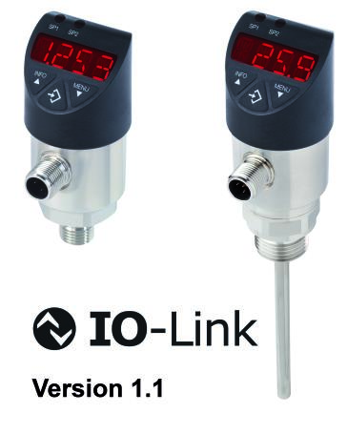

Edited by:
WIKA Alexander Wiegand SE & Co. KG
André Habel Nunes
Marketing Services
Alexander-Wiegand-Straße 30
63911 Klingenberg/Germany
Tel. +49 9372 132-8010
Fax:+49 9372 132-8008010
andre.habel-nunes@wika.com
www.wika.com

WIKA press release 12/2015

