Tubeskin temperature measurements:
New WIKA brochure

Klingenberg, October 2013.
Wika presents its portfolio within the area of tubeskin temperature measurement in a new brochure. The document is aimed primarily at companies in the process and petrochemical industries.

Since the integration of Gayesco (USA) the WIKA Group has taken the leading position in this segment of electrical temperature measurement: They deliver more than 120,000 tubeskin sensors worldwide. In addition to individual sensor designs and their applications, the brochure focuses on the associated services, from on-site consultation through to installation.

The information brochure is available in a printed format, or it can be downloaded as an e-book from the website www.wika.com.

Number of characters: 755
Key words: Brochure “Tubeskin temperature measurements”

Manufacturer:
WIKA Alexander Wiegand SE & Co. KG
Alexander-Wiegand-Straße 30
63911 Klingenberg/Germany
Tel. +49 9372 132-0
Fax: +49 9372 132-406
vertrieb@wika.com
www.wika.com

WIKA company photograph:
Brochure “Tubeskin temperature measurements”

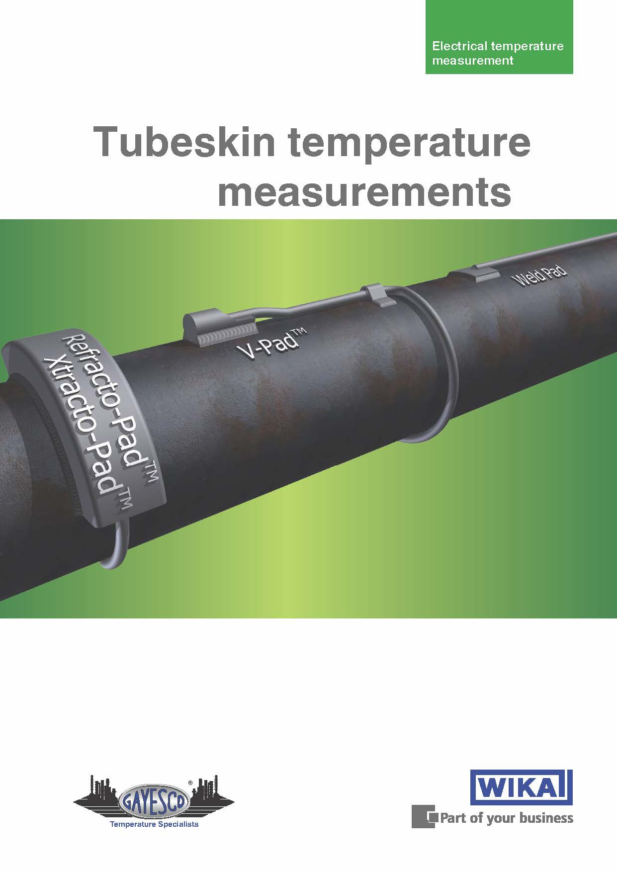

Edited by:
WIKA Alexander Wiegand SE & Co. KG
André Habel Nunes
Marketing Services
Alexander-Wiegand-Straße 30
63911 Klingenberg/Germany
Tel. +49 9372 132-8010
Fax: +49 9372 132-8008010
andre.habel-nunes@wika.com
www.wika.com

WIKA press release 13/2013

