WIKA blogs about know-how,
products and the company itself

Klingenberg, July 2015.
The new blog concept from WIKA offers the reader further information and a new insight into the group of companies. All articles can be found through the central portal “blog.wika.com”.

The contents are divided into four categories. The headings “products”, “applications” and “know-how” are full of bulletins on all segments of the WIKA product family. Under the additional heading “WIKA insight”, a wide variety of information on the worldwide WIKA Group can be found.

With this new concept, WIKA has unified its previous blog offering. The blog is matched to the design of the website and is optimised for use on mobile devices.

Number of characters: 629
Key words: WIKA blog

Manufacturer:
WIKA Alexander Wiegand SE & Co. KG
Alexander-Wiegand-Straße 30
63911 Klingenberg/Germany
Tel. +49 9372 132-0
Fax +49 9372 132-406
vertrieb@wika.com
www.wika.de

WIKA company photograph:
WIKA blog “blog.wika.de”

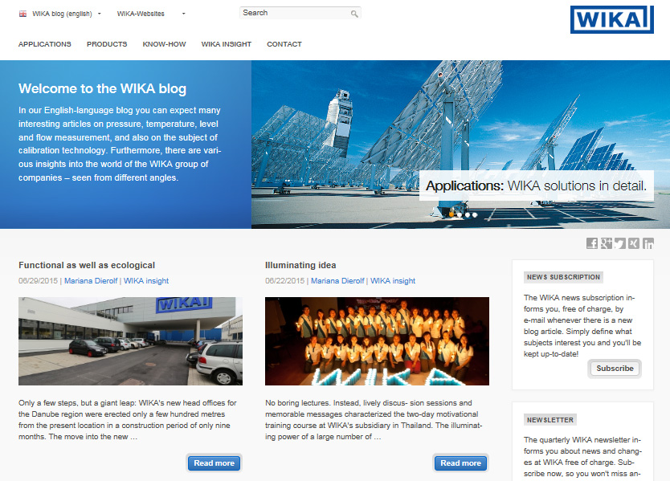

Edited by:
WIKA Alexander Wiegand SE & Co. KG
André Habel Nunes
Marketing Services
Alexander-Wiegand-Straße 30
63911 Klingenberg/Germany
Tel. +49 9372 132-8010
Fax +49 9372 132-8008010
andre.habel-nunes@wika.com
www.wika.de

WIKA press release 16/2015

