New calibrator for hazardous areas

Klingenberg, July 2012.
WIKA has now extended its portfolio of hand-held measuring instruments to include the model CPH65I0 intrinsically safe pressure calibrator. With an accuracy of 0.025 % of span and various additional functions, the new instrument is suited to a wide range of applications, and due to its ATEX approval, these also include hazardous areas.

The new hand-held is available with either one or two built-in reference pressure sensors. This allows 24 different measuring ranges of up to 700 bar to be covered. In addition, the CPH65I0 accepts transmitter output signals (0 ... 24 mA) and the ambient and medium temperature (-40 ... +150 °C) is measured by a resistance thermometer. A pressure switch test function completes the functionality. Thus users can calibrate all types of pressure measuring instruments with the new calibrator.

Although it is multi-functional, the robust CPH65I0 is simple to operate using just three keys. On the five-digit, backlit display, three measurement parameters can be displayed simultaneously. The battery power supply is designed for at least 35 hours of operation.

Number of characters: 1151
Key words: Hand-held CPH65I0

Manufacturer:
WIKA Alexander Wiegand SE & Co. KG
Alexander-Wiegand-Straße 30
63911 Klingenberg/Germany
Tel. +49 (0)9372 1320
Fax +49 (0)9372 132406
sales@wika.de
www.wika.com

WIKA company photograph:
Pressure calibrator model CPH65I0

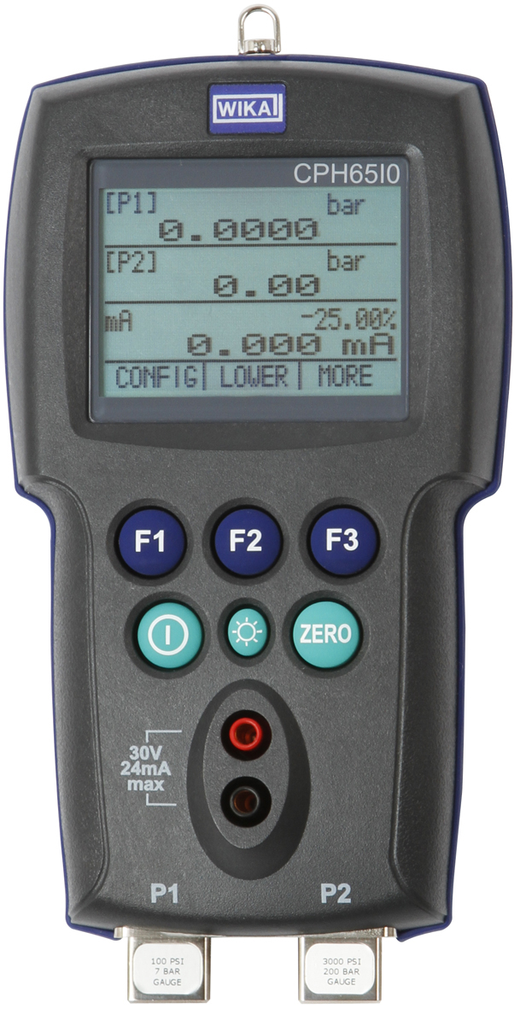

Edited by:
WIKA Alexander Wiegand SE & Co. KG
André Habel Nunes
Marketing Services
Alexander-Wiegand-Straße 30
63911 Klingenberg/Germany
Tel. +49 (0)9372 132-8010
Fax +49 (0)9372 132-8008010
a.habel-nunes@wika.de
www.wika.com

WIKA press release 17/2012

