R-1 pressure sensor now
fully CO₂ compatible

Klingenberg, October 2012.
Due to its environmental compatibility, CO₂ is increasingly establishing itself as a refrigerant in industrial applications. Thus, the model R-1 pressure transmitter from WIKA, tailored to the needs of refrigeration and air-conditioning technology, now also offers complete compatibility with the requirements of CO₂ refrigeration plants.

With this instrument, designed specifically for refrigeration systems,pressures from 100 to 160 bar, which are typical for CO₂ applications, can also be covered. The hermetically welded measuring cell reduces the likelihood of leakage to zero. Its thin-film sensor, made using sputtering technology, distinguishes itself with its high long-term stability and excellent overpressure safety.

The compact R-1, with its robust design and gasket-free process connection, has been proven in applications with traditional refrigerants for a long time. In addition to its high medium temperature range and its excellent performance, the transmitter features an attractive price/performance ratio.

Number of characters: 1099
Key word: R-1

Manufacturer:
WIKA Alexander Wiegand SE & Co. KG
Alexander-Wiegand-Straße 30
63911 Klingenberg/Germany
Tel. +49 (0)9372 1320
Fax +49 (0)9372 132406
sales@wika.de
www.wika.com

WIKA company photograph:
Pressure transmitter R-1

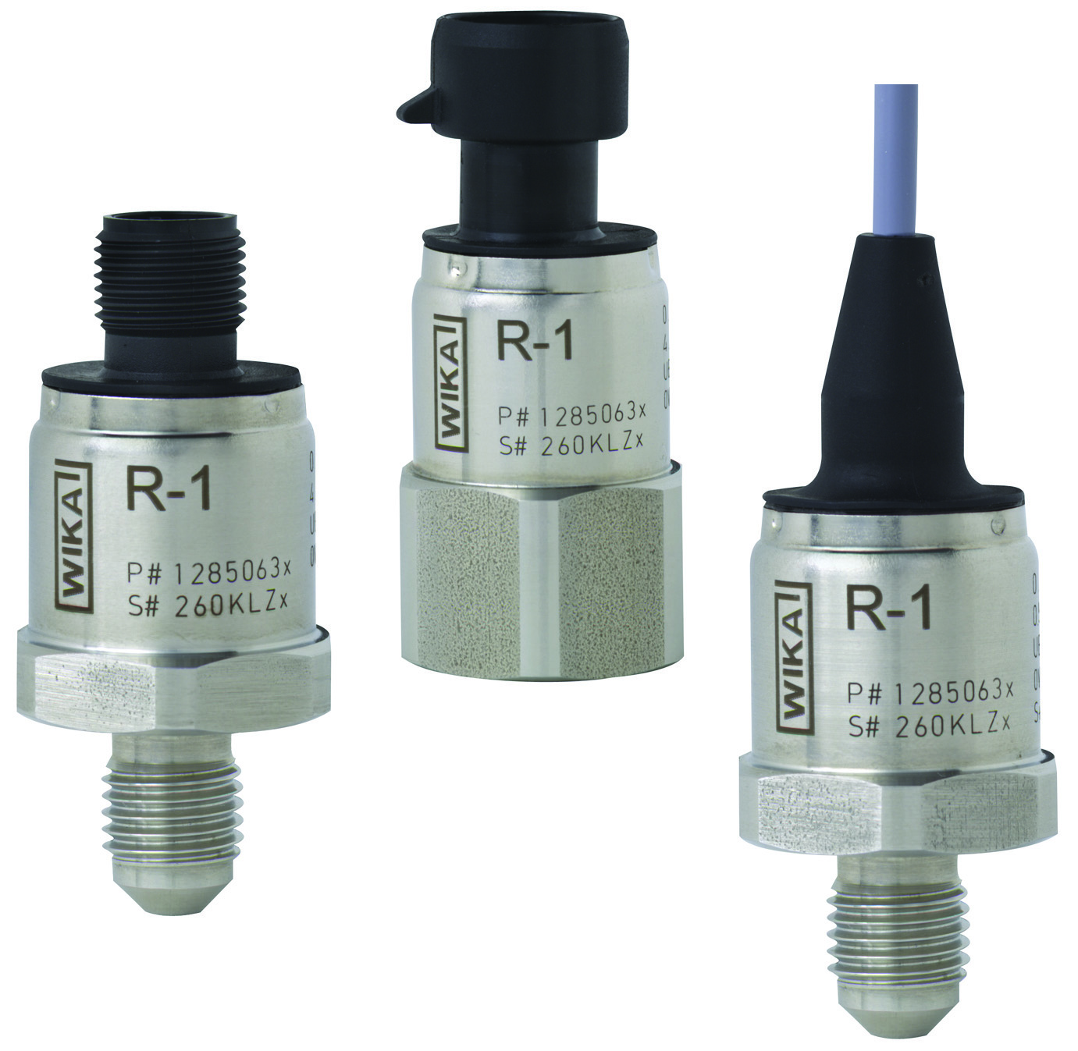

Edited by:
WIKA Alexander Wiegand SE & Co. KG
André Habel Nunes
Marketing Services
Alexander-Wiegand-Straße 30
63911 Klingenberg/Germany
Tel. +49 (0)9372 132-8010
Fax +49 (0)9372 132-8008010
a.habel-nunes@wika.de
www.wika.com

WIKA press release 22/2012

