Miniature thermometers now also with CSA seal of approval for “Ex i”

Klingenberg, December 2015
New certificate for the intrinsically safe versions of the new miniature resistance thermometers from WIKA: The models TR21, TR31 (OEM) and TR34 now also have the CSA test mark for ignition protection type Ex i.

The seal of the CSA Group (Canadian Standards Association) facilitates the use of thermometers in North America. In addition, all three instrument types have ATEX and IECEx approval. The new miniature thermometers are designed for use in a multitude of industrial applications. Their design is extremely durable, and an autoclavable version is available for sanitary applications. All models are designed for a temperature range of -50 ... +250 °C.

Number of characters: 695
Key word: TR21, TR31, TR34

Manufacturer:
WIKA Alexander Wiegand SE & Co. KG
Alexander-Wiegand-Straße 30
63911 Klingenberg/Germany
Tel. +49 9372 132-0
Fax +49 9372 132-406
vertrieb@wika.com
www.wika.de

WIKA company photograph:
Miniature thermometers TR21-A, B, C and TR34

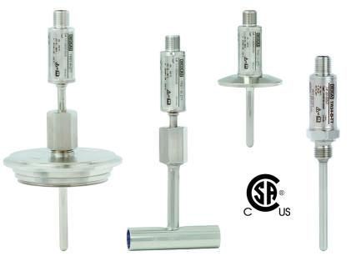

Edited by:
WIKA Alexander Wiegand SE & Co. KG
André Habel Nunes
Marketing Services
Alexander-Wiegand-Straße 30
63911 Klingenberg/Germany
Tel. +49 9372 132-8010
Fax +49 9372 132-8008010
andre.habel-nunes@wika.com
www.wika.de

WIKA press release 25/2015

